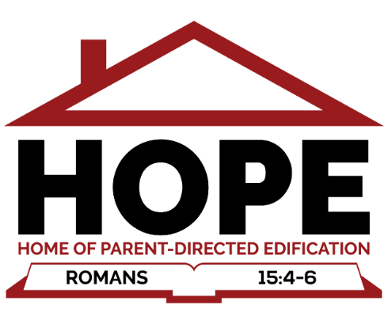

H.O.P.E., Inc. is a charitable, religious organization, 5013c.
Mission statement: to support and advance the customized and religious, biblical worldview instruction of children in the greater, central Indiana area as directed by their parents or guardians.

Goals:

I. Minister to Christian Families and to glorify the Lord.
- To glorify God by supporting parents in raising their children in the discipline and instruction of the Lord (Ephesians 6:4)
- How: To come alongside parents in offering a homeschooling center where families of like-mindedness can support one another and provide classes and opportunities for Christian instruction, growth, and development of children.
- Class offerings would be enrichment classes to core academics, Bible and Worldview, life skills, sports, theater, industrial arts, electives, career guidance, college prep, and more.

II. Serve each other and the community.
- Serve the community in various ways with numerous service opportunities and build awareness and exposure to the various ways to serve in public and religious organizations.
- To model leadership and administrative skills and to develop these skills in children.
- To be a team, to work on projects together, to encourage one another, and to bring glory to God by word and deed.

III. Support Other Christian Ministries
- Provide a place where many ministries can share facilities and costs (conference rooms, break rooms, copying rooms, etc.)
- Provide a place for start-up church or church plants.
- Provide opportunities for adults and families with Bible studies, counseling, workshops, events, and life skills.

